LAB 7
NAME: Hajra Sarwar REG NO: 2023-BSE-022
CLASS: BSE-5A
SUBJECT: CC

LAB TITLE: Environment Variables, PATH, UFW, and SSH Key Authentication

TASK:

Task 1: Print & Filter Environment Variables

Goal:
Show environment variables and filter them using grep.
- Print all environment variables
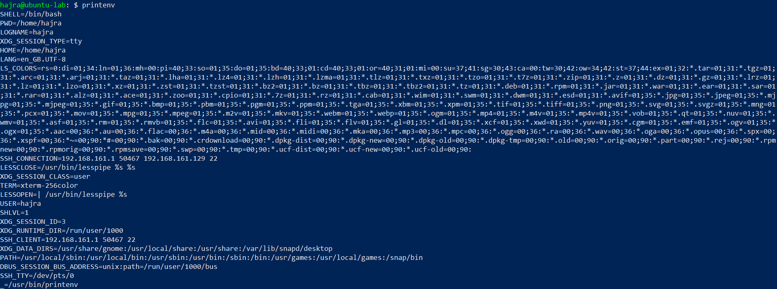
- Filter for SHELL, HOME, USER
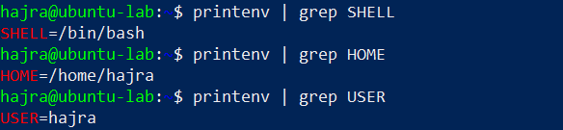

Task 2: Export DB_ Variables Temporarily and Observe Scope

Goal:
Create environment variables with export in the current shell, verify them, then close the shell and confirm the variables disappear.
- Define all DB_ variables
- Echo the three variables
- Show all DB_ variables using grep
- Close and reopen the shell — verify variables are gone

Screenshort:



Task 3: Make DB_ Variables Persistent in ~/.bashrc*

Goal:
Add DB_* variables to ~/.bashrc, reload the file, and verify persistence.
- Add the DB_ variables inside ~/.bashrc*
- Source ~/.bashrc and verify
- Close and reopen the terminal — verify persistence

Screenshort:



Task 4: System-wide Environment Variable, Welcome Script, and PATH

Goal:
Add a system-wide Class variable to /etc/environment, view PATH, create a welcome script, make it executable, and add a PATH entry to ~/.bashrc so the script can run without ./.
- View /etc/environment
- Show current PATH
- Edit /etc/environment to add Class variable
- Re-login / open new shell — show Class and PATH together
- Create welcome script and make it executable

- Run the script using ./welcome

- Add PATH entry to ~/.bashrc
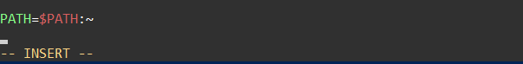
- Apply changes and run welcome without ./


Task 5 — Block and Allow SSH Using UFW (Firewall)

Goal:
Use ufw to deny and allow SSH access, then verify the connectivity changes from the Windows host.
- Enable UFW and show its status
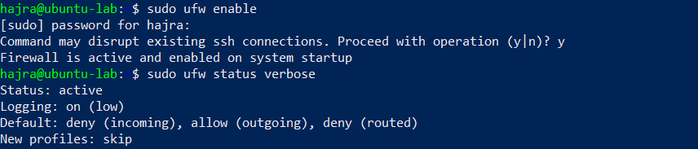

- Deny SSH (port 22) and show numbered status
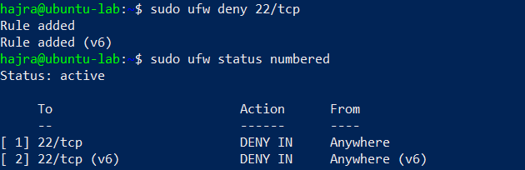
- From Windows host — attempt SSH (should fail)
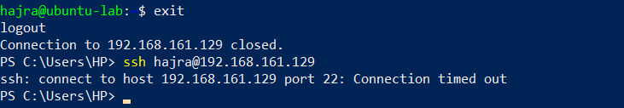
- Allow SSH again, reload UFW, and show status
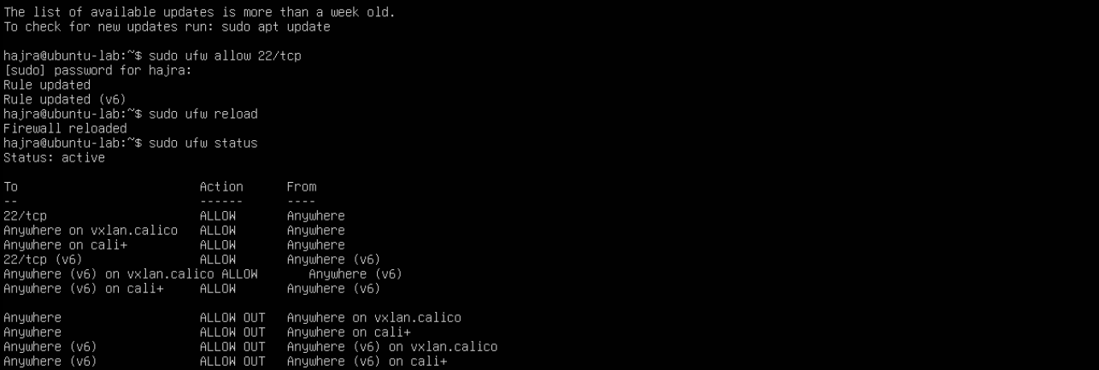
- From Windows host — attempt SSH again (should succeed)

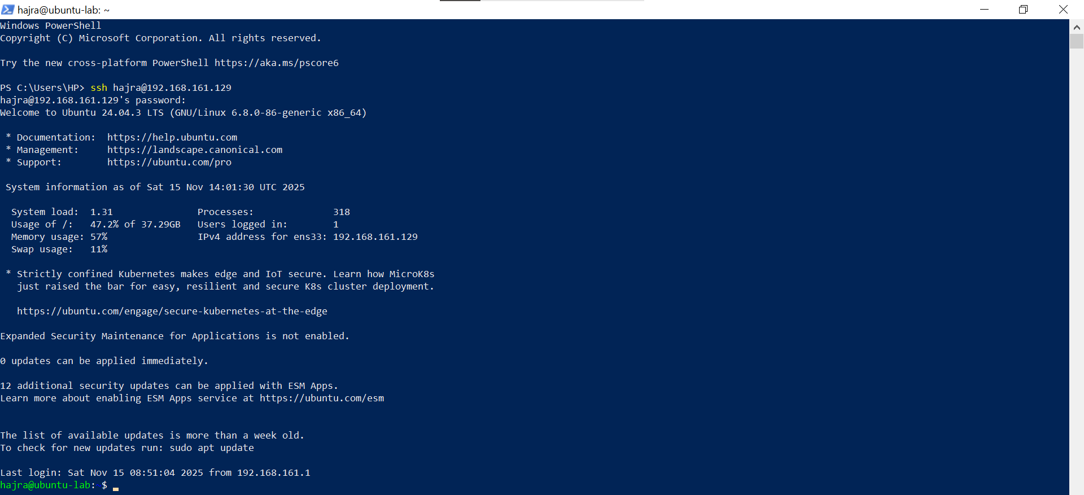

Task 6 — Configure SSH Key-Based Login from Windows Host

Goal:
Copy the Windows client’s public key into the Ubuntu server’s ~/.ssh/authorized_keys to enable passwordless SSH.

A. Windows Host (Client-Side Steps)
- Generate SSH key pair and list .ssh directory
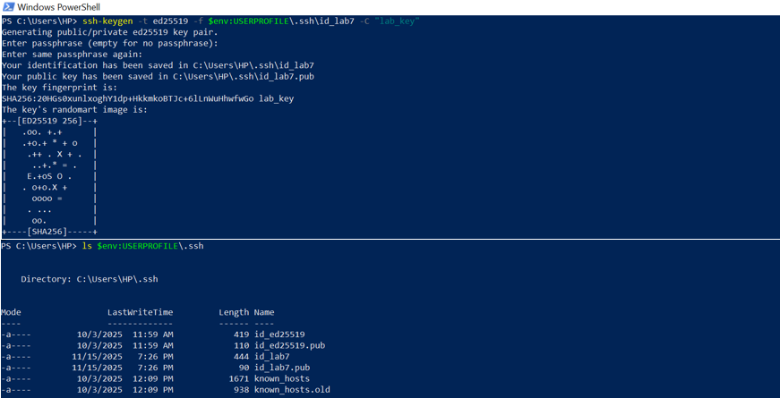
- Show the public key content
- Clear the known_hosts file and verify it is empty
- Connect to Ubuntu server — capture host-key acceptance
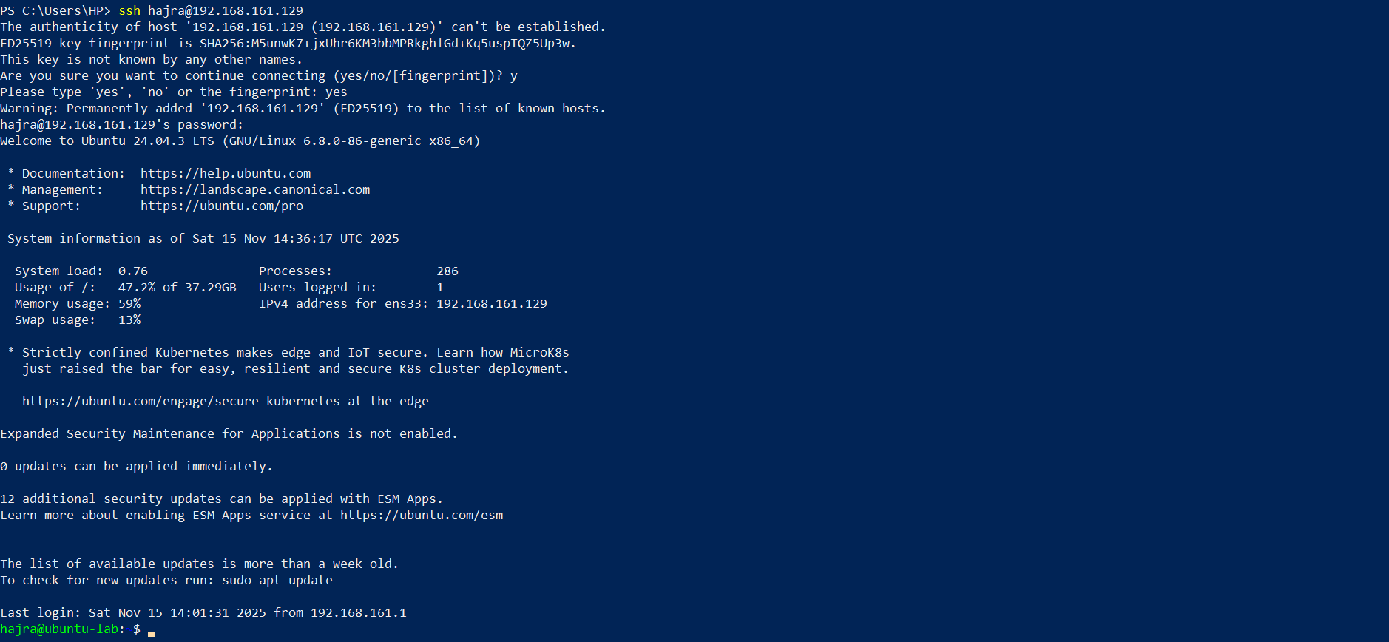
- After login, show known_hosts file updated

B. Ubuntu Server (Server-Side Steps)
- Prepare .ssh directory and clear authorized_keys

- Add the public key, set permissions, and display file

C. Test Passwordless SSH
- From Windows — confirm passwordless login
- Also test using explicit identity file
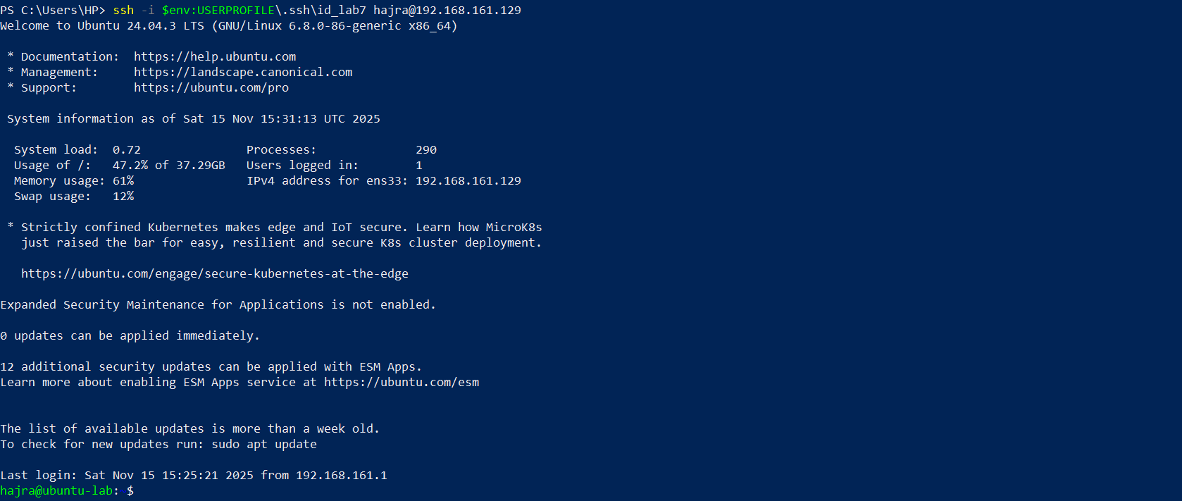

Exam Evaluation Questions

Q1 — Quick Environment Audit

Objective:
Demonstrate you can inspect the current environment and extract a few key variables.

Actions & Evidence:
- Display all environment variables:

- Filter for PATH, LANG, and PWD (run 3 commands, capture together):
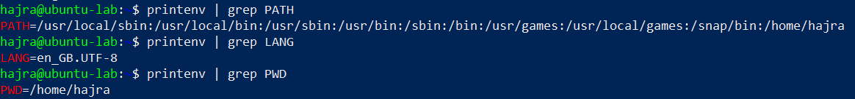

Q2 — Short-Lived Student Info

Objective:
Show how temporary environment variables behave (session-scoped).

Actions & Evidence:
- Set three variables consecutively and capture commands + execution:

- Print all three variables (grouped) and capture output:
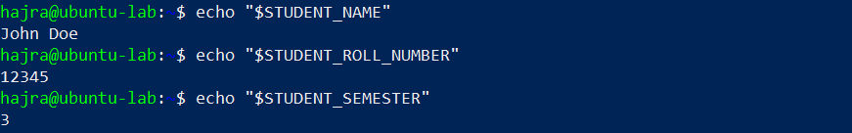
- Use printenv | grep to show any STUDENT_ variables:

- Exit shell, open new terminal, show variables are gone:
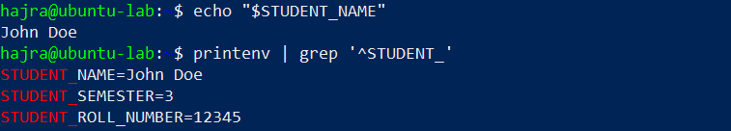

Q3 — Make It Sticky (Persistent Student Info)

Objective:
Demonstrate persistence of environment variables across sessions via ~/.bashrc.

Actions & Evidence:
- Edit ~/.bashrc and append the three STUDENT_* exports. Capture editor screenshot:
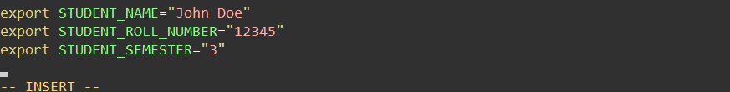
- Reload shell config and verify variables + printenv grep together:
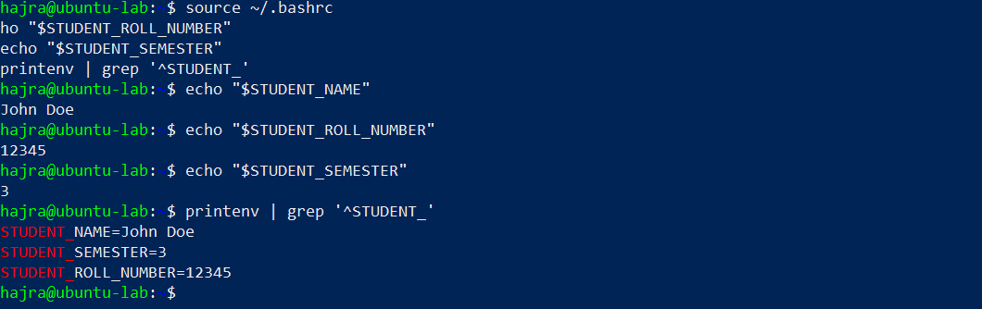
- Close and reopen terminal — verify STUDENT_NAME persists:
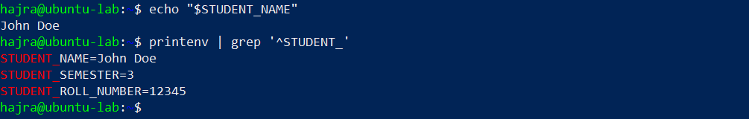

Q4 — Firewall Rules: Block and Restore Ping (ICMP)

Objective:
Block ping (ICMP echo) traffic using ufw and then re-allow it; show effect from a client.

Actions & Evidence:
- Enable ufw and show status (group commands):
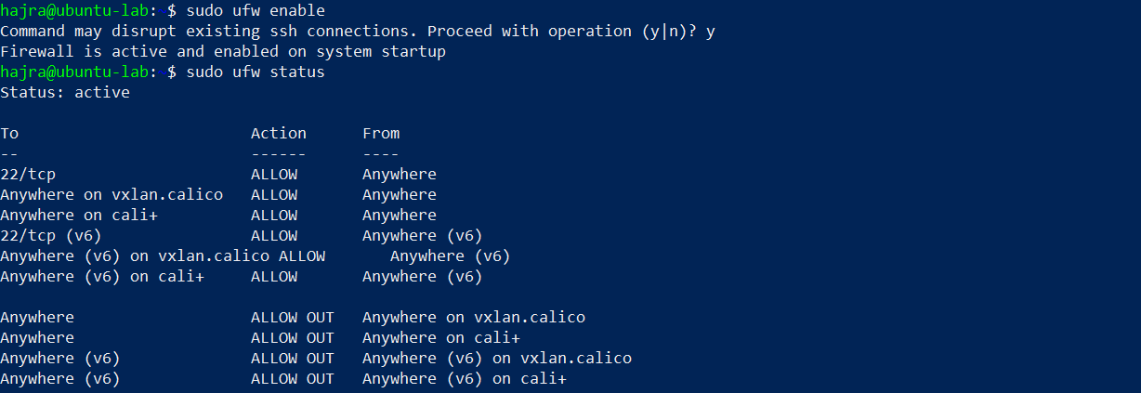
- Block ping (ICMP) and show numbered status:
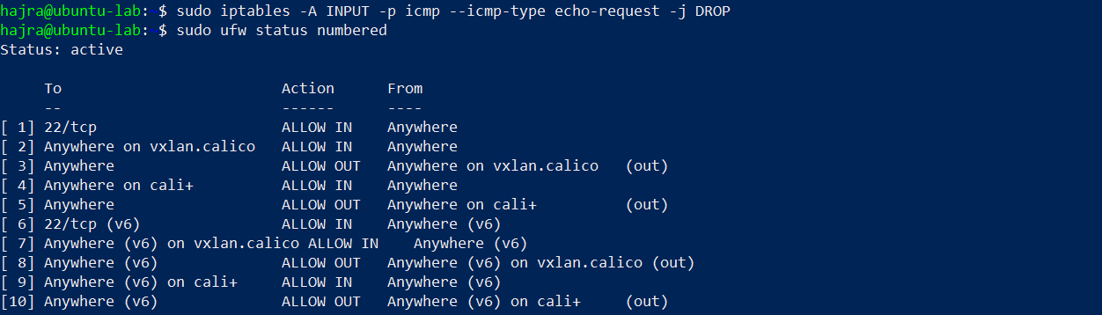
- From Windows host (or another client) — attempt ping while blocked:
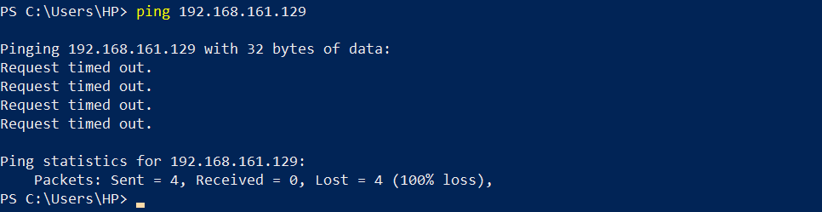
- Re-allow ping and show allow/reload/status together:
- From client, ping server again — capture successful replies:
